Nama: Isep Lutpi Nur

NPM: 2113191079

Tugas: Minggu 5 - WEIGHT AGGREGATED SUM PRODUCK ASSESMENT (WASPAS)

**Buatlah kasus dengan penyelesaian waspas**

**Studi Kasus:** Penentuan asisten laboratorium menggunakan metode WASPAS

**Data:**

**Bobot Kriteria:**

Nilai Ujian = 0.6

IPK = 0.25

Semester = 0.15

Cost (Min) = {Nilai Ujian, IPK}

Benefit (Max) = {Semester}

**Table data:**

|  |  |  |  |  |
| --- | --- | --- | --- | --- |
| No. | Nama | NU | IPK | Smstr |
| 1 | Rivan kurnia | 70 | 3.20 | 6 |
| 2 | Adistia Ramadhani | 80 | 3.30 | 6 |
| 3 | Akbar Maulana | 85 | 3.50 | 4 |
| 4 | Alam Nurzaman | 75 | 3.10 | 6 |
| 5 | Dara Atria | 85 | 3.70 | 6 |
| 6 | Deri Kurniawan | 80 | 3.30 | 4 |
| 7 | Farhan Aziz | 70 | 3.30 | 4 |
| 8 | Iman Faturahman | 75 | 3.20 | 6 |
| 9 | Irfan Ramdani | 80 | 3.40 | 4 |
| 10 | Isep Lutpi Nur | 90 | 3.70 | 4 |

**Implementasi**:

1. Membuat Matriks Keputusan

|  |  |  |  |
| --- | --- | --- | --- |
| **X=** | 70 | 3.20 | 6 |
|  | 80 | 3.30 | 6 |
|  | 85 | 3.50 | 4 |
|  | 75 | 3.10 | 6 |
|  | 85 | 3.70 | 6 |
|  | 80 | 3.30 | 4 |
|  | 70 | 3.30 | 4 |
|  | 75 | 3.20 | 6 |
|  | 80 | 3.40 | 4 |
|  | 90 | 3.70 | 4 |

|  |  |  |  |  |
| --- | --- | --- | --- | --- |
| No. | Nama | NU | IPK | Smstr |
| 1 | Rivan kurnia | 70 | 3.20 | 6 |
| 2 | Adistia Ramadhani | 80 | 3.30 | 6 |
| 3 | Akbar Maulana | 85 | 3.50 | 4 |
| 4 | Alam Nurzaman | 75 | 3.10 | 6 |
| 5 | Dara Atria | 85 | 3.70 | 6 |
| 6 | Deri Kurniawan | 80 | 3.30 | 4 |
| 7 | Farhan Aziz | 70 | 3.30 | 4 |
| 8 | Iman Faturahman | 75 | 3.20 | 6 |
| 9 | Irfan Ramdani | 80 | 3.40 | 4 |
| 10 | Isep Lutpi Nur | 90 | 3.70 | 4 |

1. Menghitung nilai normalisasi Matriks setiap kriteria
2. Kriteria Nilai Ujian -> Cost(Min) -> $X_{ij}=\frac{{Min}_{i}X_{ij}}{X_{ij}}$

|  |  |  |  |  |
| --- | --- | --- | --- | --- |
|  | i | **NU** | IPK | Smstr |
| **X=** | 1 | **70** | 3.2 | 6 |
| 2 | **80** | 3.3 | 6 |
| 3 | **85** | 3.5 | 4 |
| 4 | **75** | 3.1 | 6 |
| 5 | **85** | 3.7 | 6 |
| 6 | **80** | 3.3 | 4 |
| 7 | **70** | 3.3 | 4 |
| 8 | **75** | 3.2 | 6 |
| 9 | **80** | 3.4 | 4 |
| 10 | **90** | 3.7 | 4 |
|  |  | **Min** | Min | Max |
|  |  | **70** | 3.1 | 6 |
|  |  | **0.60** | 0.25 | 0.15 |

$$X_{1,1}=\frac{70}{70}=1$$

$$X_{2,1}=\frac{70}{80}=0.875$$

$$X_{3,1}=\frac{70}{85}=0.824$$

$$X_{4,1}=\frac{70}{75}=0.933$$

$$X_{5,1}=\frac{70}{85}=0.824$$

$$X_{6,1}=\frac{70}{80}=0.875$$

$$X_{7,1}=\frac{70}{70}=1$$

$$X_{8,1}=\frac{70}{75}=0.933$$

$$X_{9,1}=\frac{70}{80}=0.875$$

$$X_{10,1}=\frac{70}{90}=0.778$$

1. Kriteria IPK -> Cost(Min) Cost(Min) -> $X_{ij}=\frac{{Min}_{i}X_{ij}}{X_{ij}}$

|  |  |  |  |  |
| --- | --- | --- | --- | --- |
|  | i | NU | **IPK** | Smstr |
| **X=** | 1 | 70 | **3.2** | 6 |
| 2 | 80 | **3.3** | 6 |
| 3 | 85 | **3.5** | 4 |
| 4 | 75 | **3.1** | 6 |
| 5 | 85 | **3.7** | 6 |
| 6 | 80 | **3.3** | 4 |
| 7 | 70 | **3.3** | 4 |
| 8 | 75 | **3.2** | 6 |
| 9 | 80 | **3.4** | 4 |
| 10 | 90 | **3.7** | 4 |
|  |  | Min | **Min** | Max |
|  |  | 70 | **3.1** | 6 |
|  |  | 0.60 | **0.25** | 0.15 |

$$X_{1,2}=\frac{3.1}{3.2}=0.969$$

$$X_{2,2}=\frac{3.1}{3.3}=0.939$$

$$X_{3,2}=\frac{3.1}{3.5}=0.886$$

$$X_{4,2}=\frac{3.1}{3.1}=1$$

$$X_{5,2}=\frac{3.1}{3.7}=0.838$$

$$X_{6,2}=\frac{3.1}{3.3}=0.939$$

$$X_{7,2}=\frac{3.1}{3.3}=0.939$$

$$X_{8,2}=\frac{3.1}{3.2}=0.969$$

$$X_{9,2}=\frac{3.1}{3.4}=0.912$$

$$X_{10,2}=\frac{3.1}{3.7}=0.838$$

1. Kriteria Semester -> Benefit(Max) -> $X_{ij}=\frac{X_{ij}}{{Max}_{i}X_{ij}}$

|  |  |  |  |  |
| --- | --- | --- | --- | --- |
|  | i | NU | IPK | **Smstr** |
| **X=** | 1 | 70 | 3.2 | **6** |
| 2 | 80 | 3.3 | **6** |
| 3 | 85 | 3.5 | **4** |
| 4 | 75 | 3.1 | **6** |
| 5 | 85 | 3.7 | **6** |
| 6 | 80 | 3.3 | **4** |
| 7 | 70 | 3.3 | **4** |
| 8 | 75 | 3.2 | **6** |
| 9 | 80 | 3.4 | **4** |
| 10 | 90 | 3.7 | **4** |
|  |  | Min | Min | **Max** |
|  |  | 70 | 3.1 | **6** |
|  |  | 0.60 | 0.25 | **0.15** |

$$X_{1,3}=\frac{6}{6}=1$$

$$X_{2,3}=\frac{6}{6}=1$$

$$X_{3,3}=\frac{4}{6}=0.667$$

$$X_{4,3}=\frac{6}{6}=1$$

$$X_{5,3}=\frac{6}{6}=1$$

$$X_{6,3}=\frac{4}{6}=0.667$$

$$X_{7,3}=\frac{4}{6}=0.667$$

$$X_{8,3}=\frac{6}{6}=1$$

$$X_{9,3}=\frac{4}{6}=0.667$$

$$X_{10,3}=\frac{4}{6}=0.667$$

1. Didapatlah normalisasi dari setiap kriteria

|  |  |  |  |
| --- | --- | --- | --- |
| **X=** | 1.000 | 0.969 | 1.000 |
| 0.875 | 0.939 | 1.000 |
| 0.824 | 0.886 | 0.667 |
| 0.933 | 1.000 | 1.000 |
| 0.824 | 0.838 | 1.000 |
| 0.875 | 0.939 | 0.667 |
| 1.000 | 0.939 | 0.667 |
| 0.933 | 0.969 | 1.000 |
| 0.875 | 0.912 | 0.667 |
| 0.778 | 0.838 | 0.667 |

|  |  |  |  |  |
| --- | --- | --- | --- | --- |
|  | i | NU | IPK | Smstr |
| **X=** | 1 | 70 | 3.2 | 6 |
| 2 | 80 | 3.3 | 6 |
| 3 | 85 | 3.5 | 4 |
| 4 | 75 | 3.1 | 6 |
| 5 | 85 | 3.7 | 6 |
| 6 | 80 | 3.3 | 4 |
| 7 | 70 | 3.3 | 4 |
| 8 | 75 | 3.2 | 6 |
| 9 | 80 | 3.4 | 4 |
| 10 | 90 | 3.7 | 4 |
|  |  | Min | Min | Max |
|  |  | 70 | 3.1 | 6 |
|  |  | 0.60 | 0.25 | 0.15 |

1. Menghitung nilai Qi dari Normalisasi dan Bobot WASPAS dalam pengambilan keputusan

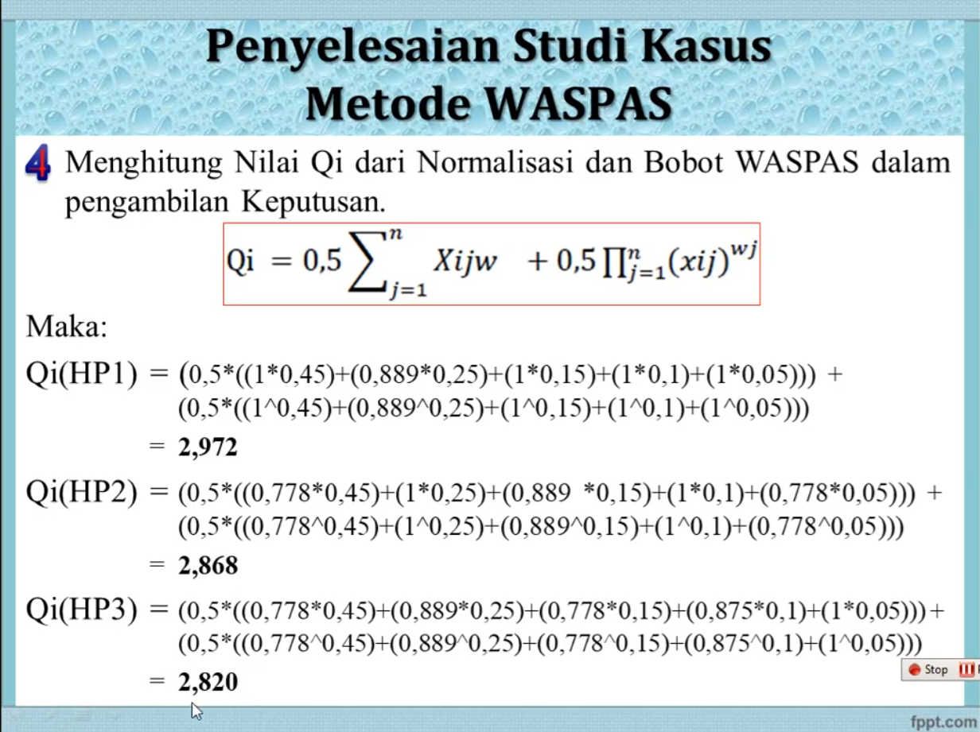

1. Perhitungan Qi
2. Qi(Rivan kurnia)
$$QiA_{1}=\left(0.5*\left(\left(1*0.6\right)+\left(1*0.25\right)+\left(1*0.15\right)\right)\right)+\left(0.5*\left(\left(1^{0.6}\right)+\left(1^{0.25}\right)+\left(1^{0.15}\right)\right)\right)=1.992$$

3. Qi(Adistia Ramadhani)
$$QiA_{2}=\left(0.5*\left(\left(0.875*0.6\right)+\left(1*0.25\right)+\left(1*0.15\right)\right)\right)+\left(0.5*\left(\left({0.875}^{0.6}\right)+\left(1^{0.25}\right)+\left(1^{0.15}\right)\right)\right)=1.909$$

4. Qi(Akbar Maulana)
$$QiA_{3}=\left(0.5*\left(\left(0.824*0.6\right)+\left(1*0.25\right)+\left(0.667*0.15\right)\right)\right)+\left(0.5*\left(\left({0.824}^{0.6}\right)+\left(1^{0.25}\right)+\left({0.667}^{0.15}\right)\right)\right)=1.808$$

5. Qi(Alam Nurzaman)
$$QiA_{4}=\left(0.5*\left(\left(0.933*0.6\right)+\left(1*0.25\right)+\left(1*0.15\right)\right)\right)+\left(0.5*\left(\left({0.933}^{0.6}\right)+\left(1^{0.25}\right)+\left(1^{0.15}\right)\right)\right)=1.96$$

6. Qi(Dara Atria)
$$QiA_{5}=\left(0.5*\left(\left(0.824*0.6\right)+\left(1*0.25\right)+\left(1*0.15\right)\right)\right)+\left(0.5*\left(\left({0.824}^{0.6}\right)+\left(1^{0.25}\right)+\left(1^{0.15}\right)\right)\right)=1.85$$

7. Qi(Deri Kurniawan)
$$QiA_{6}=\left(0.5*\left(\left(0.875*0.6\right)+\left(1*0.25\right)+\left(0.667*0.15\right)\right)\right)+\left(0.5*\left(\left({0.875}^{0.6}\right)+\left(1^{0.25}\right)+\left({0.667}^{0.15}\right)\right)\right)=1.854$$

8. Qi(Farhan Aziz)
$$QiA_{7}=\left(0.5*\left(\left(1*0.6\right)+\left(1*0.25\right)+\left(0.667*0.15\right)\right)\right)+\left(0.5*\left(\left(1^{0.6}\right)+\left(1^{0.25}\right)+\left({0.667}^{0.15}\right)\right)\right)=1.93$$

9. Qi(Iman Faturahman)
$$QiA_{8}=\left(0.5*\left(\left(0.933*0.6\right)+\left(1*0.25\right)+\left(1*0.15\right)\right)\right)+\left(0.5*\left(\left({0.933}^{0.6}\right)+\left(1^{0.25}\right)+\left(1^{0.15}\right)\right)\right)=1.952$$

10. Qi(Irfan Ramdani)
$$QiA_{9}=\left(0.5*\left(\left(0.875*0.6\right)+\left(1*0.25\right)+\left(0.667*0.15\right)\right)\right)+\left(0.5*\left(\left({0.875}^{0.6}\right)+\left(1^{0.25}\right)+\left({0.667}^{0.15}\right)\right)\right)=1.847$$

11. Qi(Isep Lutpi Nur)
$$QiA_{10}=\left(0.5*\left(\left(0.778*0.6\right)+\left(1*0.25\right)+\left(0.667*0.15\right)\right)\right)+\left(0.5*\left(\left({0.778}^{0.6}\right)+\left(1^{0.25}\right)+\left({0.667}^{0.15}\right)\right)\right)=1.767$$

12. Perangkingan dan hasil perhitungan.

|  |  |  |  |
| --- | --- | --- | --- |
| No. | Nama | Nilai Qi | Rangking |
| 1 | Rivan kurnia | 1.992 | 1 |
| 2 | Adistia Ramadhani | 1.909 | 5 |
| 3 | Akbar Maulana | 1.808 | 9 |
| 4 | Alam Nurzaman | 1.96 | 2 |
| 5 | Dara Atria | 1.85 | 7 |
| 6 | Deri Kurniawan | 1.854 | 6 |
| 7 | Farhan Aziz | 1.93 | 4 |
| 8 | Iman Faturahman | 1.952 | 3 |
| 9 | Irfan Ramdani | 1.847 | 8 |
| 10 | Isep Lutpi Nur | 1.767 | 10 |

1. Perhitungan

Perhitungan menggunakan Microsoft Excel

